Tugas project UAS Grafika komputer

Nama : Ida Musdalifah

Nim : D0221358

Kelas : Informatika G

LINK GITHUB

<https://github.com/idamusdalifah/Grafika-USB/upload/main/Tugas%20Besar>

LINK YOUTUBE

<https://youtu.be/odFN9IJyKcE?si=iz8tEzMRZdZLcq0d>

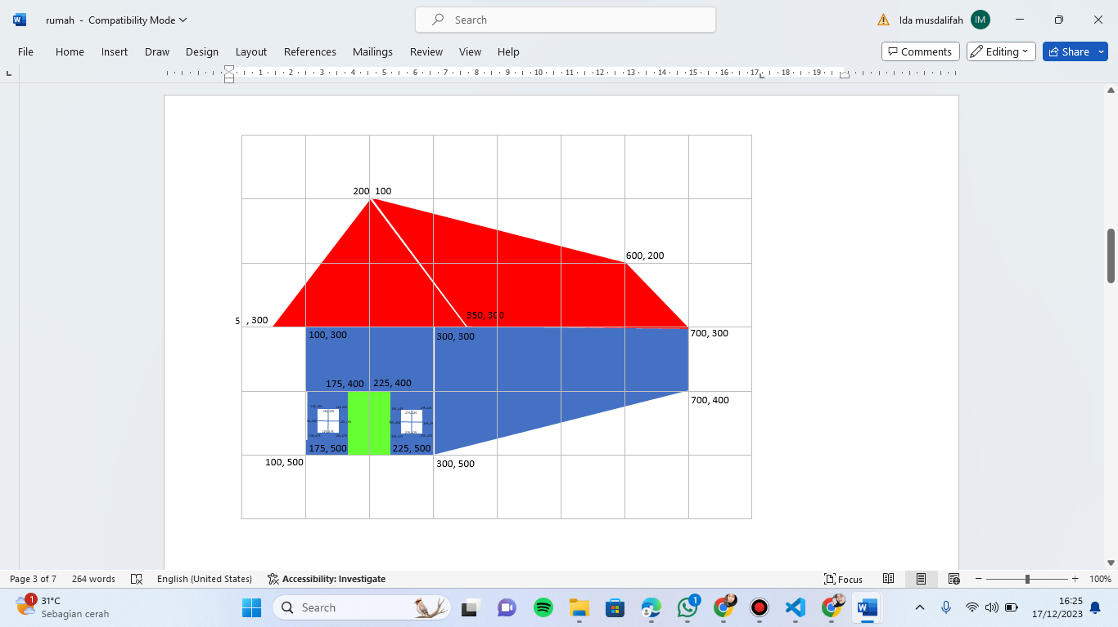

import pygame

from pygame.locals import *

from OpenGL.GL import *

from OpenGL.GLUT import *

from OpenGL.GLU import *

def draw_house():

glColor3f(0.0, 0.0, 1.0)

glBegin(GL_QUADS)

glVertex2f(100, 500)

glVertex2f(100, 300)

glVertex2f(300, 300)

glVertex2f(300, 500)

glEnd()

glColor3f(0.0, 0.0, 1.0)

glBegin(GL_QUADS)

glVertex2f(300, 500)

glVertex2f(300, 300)

glVertex2f(700, 300)

glVertex2f(700, 400)

glEnd()

glColor3f(1.0, 0.0, 0.0)

glBegin(GL_QUADS)

glVertex2f(350, 300)

glVertex2f(200, 100)

glVertex2f(600, 200)

glVertex2f(700, 300)

glEnd()

glColor3f(1.0, 0.0, 0.0)

glBegin(GL_TRIANGLES)

glVertex2f(50, 300)

glVertex2f(200, 100)

glVertex2f(350, 300)

glEnd()

glColor3f(0.0, 1.0, 0.0)

glBegin(GL_QUADS)

glVertex2f(175, 400)

glVertex2f(175, 500)

glVertex2f(225, 500)

glVertex2f(225, 400)

glEnd()

glColor3f(1.0, 1.0, 1.0)

glBegin(GL_QUADS)

glVertex2f(105, 475)

glVertex2f(105, 425)

glVertex2f(145, 425)

glVertex2f(145, 475)

glEnd()

glColor3f(0.0, 0.0, 1.0)

glBegin(GL_LINES)

glVertex2f(105, 450)

glVertex2f(145, 450)

glEnd()

glColor3f(0.0, 0.0, 1.0)

glBegin(GL_LINES)

glVertex2f(125, 425)

glVertex2f(125, 475)

glEnd()

glColor3f(1.0, 1.0, 1.0)

glBegin(GL_QUADS)

glVertex2f(255, 475)

glVertex2f(255, 425)

glVertex2f(295, 425)

glVertex2f(295, 475)

glEnd()

glColor3f(0.0, 0.0, 1.0)

glBegin(GL_LINES)

glVertex2f(255, 450)

glVertex2f(295, 450)

glEnd()

glColor3f(0.0, 0.0, 1.0)

glBegin(GL_LINES)

glVertex2f(275, 425)

glVertex2f(275, 475)

glEnd()

def main():

pygame.init()

display = (800, 600)

pygame.display.set_mode(display, DOUBLEBUF | OPENGL)

gluOrtho2D(0, display[0], display[1], 0)

while True:

for event in pygame.event.get():

if event.type == pygame.QUIT:

pygame.quit()

quit()

glClear(GL_COLOR_BUFFER_BIT | GL_DEPTH_BUFFER_BIT)

draw_house()

pygame.display.flip()

pygame.time.wait(10)

if __name__ == "__main__":

main()

